Ideation Phase
Define the Problem Statements

Date | 08 Febrauary 2026
Team ID | LTVIP2026TMIDS66040
Project Name | IntelliSQL: Intelligent SQL Querying with LLMs Using Gemini Pro
Maximum Marks | 2 Marks

Customer Problem Statement Template:
Create a problem statement to understand your customer's point of view. The Customer Problem Statement template helps you focus on what matters to create experiences people will love.
Problem  Statement (PS) | I am  (Customer) | I’m trying to | But | Because | Which makes me feel
PS-1 | data analyst or nontechnical | retrieve insights from databases | I struggle to write correct | SQL syntax requires technical | frustrated, timeconsuming, and dependent on technical
A well-articulated customer problem statement allows you and your team to find the ideal solution for the challenges your customers face. Throughout the process, you’ll also be able to empathize with your customers, which helps you better understand how they perceive your product or service.
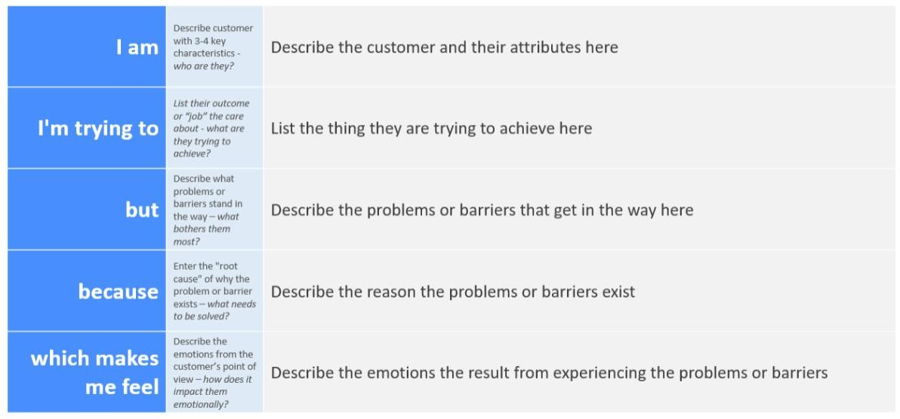
Reference: https://miro.com/templates/customer-problem-statement/ Example:

 | business user. | using SQL queries. | and  optimized SQL  queries, especially for  complex  joins, aggregati ons, and nested queries. | expertise and a strong understandin g of database schemas and relationships | teams for simple data retrieval tasks.
PS-2 | a software developer or database administrato  r. | help users efficiently access and analyze structured data stored in relational databases. | manual query  writing,  debuggin g, and supportin g nontechnical users  consume significan t time and resources. | users often lack SQL knowledge and frequently make syntax or logical errors in their queries. | overloaded with repetitive support requests, reducing overall productivity and efficiency.

